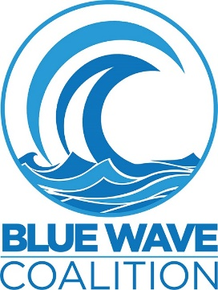
PRESS RELEASE
Embargoed 7/30/20

FLORIDA CHILDREN IMPLORE ADULTS TO VOTE IN 2020 FOR A BETTER TOMORROW

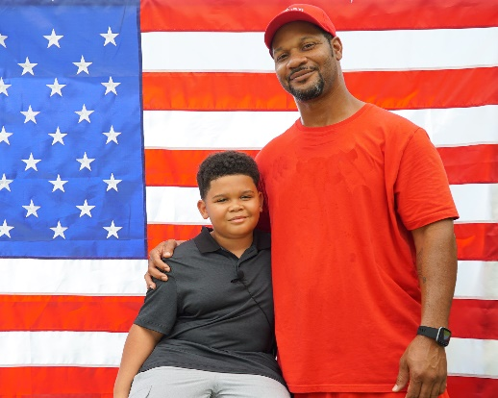
A compelling new PSA called We the People is being launched in which diverse children as young as age 4 urge adults to create the conditions for a more promising future. The campaign encourages viewers to remember fundamental yet important values, imploring them to vote in November.

Filmed and produced entirely by volunteers, the urgent non-partisan message is that Americans everywhere should make their voices heard by voting for leaders who are ready to stand up for both their own and their children’s basic human rights and an environment in which we all can flourish and thrive.

Mr. Perkins, the father of a ten-year old boy featured in the campaign, was excited to have his son involved in the production. He said, “The heart of a child is what we all need to make this world a better place. This has always been my belief. So, this ad represents something very personal to me. I hope that it resonates in everyone as it does for me, like a ray of sunshine and a breath of fresh air.” He continued, “I am hopeful that its powerful message will be the driving force to expand the hearts and minds of those who have been obstructed with hate, anger and fear.”

Directed by Emmy-award winning director Shannon Hart and produced by Blue Wave Coalition, filming took place outdoors amid the coronavirus epidemic and the heat of the Florida summer. Participants and their families surmounted these challenges because of their belief in the urgency of the message. Ms. Hart said “I was so impressed by how many families came out to support this message on one of the hottest days of the year so far. It’s important that we remind each other of the values we share and how critical it is that those values are represented in the upcoming election.”

Robin Dion, Chair of the Blue Wave Coalition, said “Children deserve to live, learn, and grow up without fear. Their well-being is important not just for them and their families but also for society in general. When children thrive, they are more likely to become productive citizens and contribute to both a strong economy and a compassionate world where everyone feels welcome and accepted. Not only is this campaign’s message relevant to the future of our children, it’s important for everyone in our nation.”

Eligere, one of the featured children, took the experience to heart. “I said my lines with passion because I understand that it's important. I sat up straight, took a deep breath, and gave it my best.”

With less than 100 days left, the goal is that wide distribution of the PSA will help inspire a tsunami of engagement and participation in the 2020 election.

The 51-second PSA is available in several formats on YouTube at the links below, including two videos and one audio-only version. A behind-the-scenes look at the filming can be viewed at https://www.bluewavecoalition.org/we-the-people-pledge. Soon to be released is an audio version in Spanish.

ENDS

For media inquiries, contact Robin Dion, bluewavecoalition@gmail.com, (703) 862-1890.

Children’s Voices: www.youtube.com/watch?v=XWr-FjqHyrg&feature=youtu.be
A Beautiful America: www.youtube.com/watch?v=hp_WjPwqQWs
Audio-Only for Radio www.bluewavecoalition.org/we-the-people-media-package
Social Media: #WeThePeoplePledge2020
For related photos, please credit “Jorge Rivera and Shannon Hart.”

